1. **Terraform.tfstate is very important file in terraform. Terraform is all about the tracking the infrastructure to modify or remove infrastructure in future. If we delete this file then terraform do not remember if any infrastructure (e.g. ec2 instance) is already created.**
2. **Do not push terraform.tfstate file to github since it contains many sensitive information like secrets, aws vpc info etc. You can store other terraform files to git expect state file.**
3. **You should store your state files remote backend(e.g. s3 bucket).**
4. **Do not try to write state file through command line(vi command) else terraform will get corrupted. Hence keep/set read access to this file for all.**
5. **I.Q. Ideal terraform setup.**

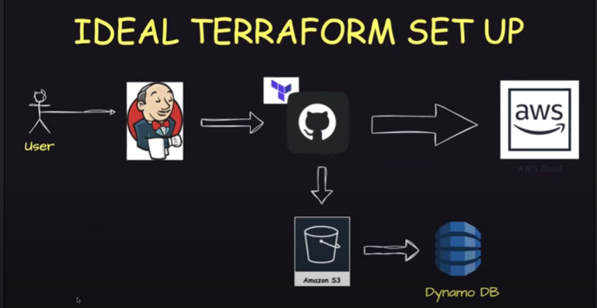

**If you are using aws, then always keep your terraform statefile in s3 bucket. It is a good practice.**

**I.Q. IMP:- Here Dynamo DB is locking solution as it locks the state file stored in s3 if observed parallel jenkin execution from users. Because it leads to misconfiguration in infrastructure and state file should be access by single user at a time.**

1. **I.Q:**

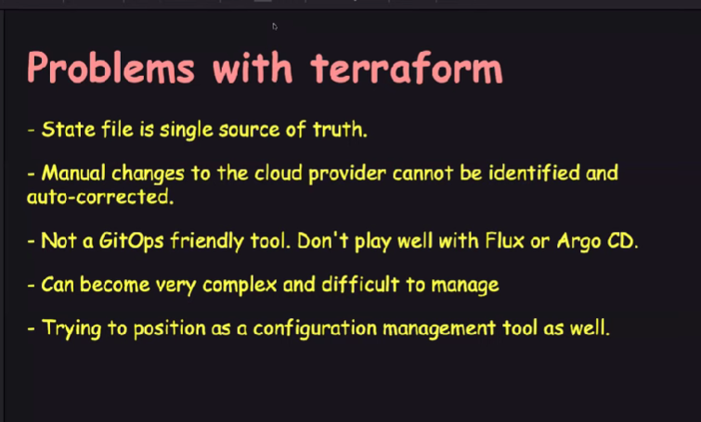

1. **I.Q. What is the modules in terraform?**
2. **I.Q. local state and remote state?**